**Installation MongoDB**

* Download the MongoDB datbabase from the link: [*https://www.mongodb.com/try/download/community*](https://www.mongodb.com/try/download/community)

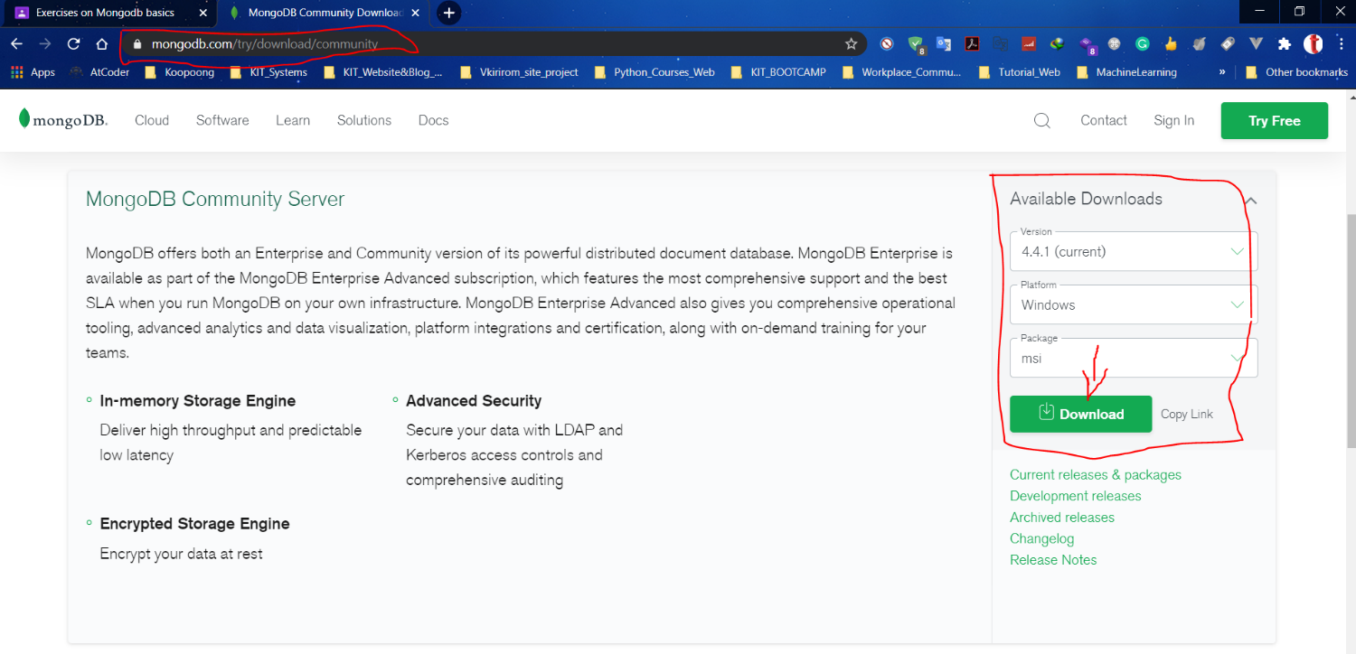

* Then follow the Step to install MongoDB into window below:

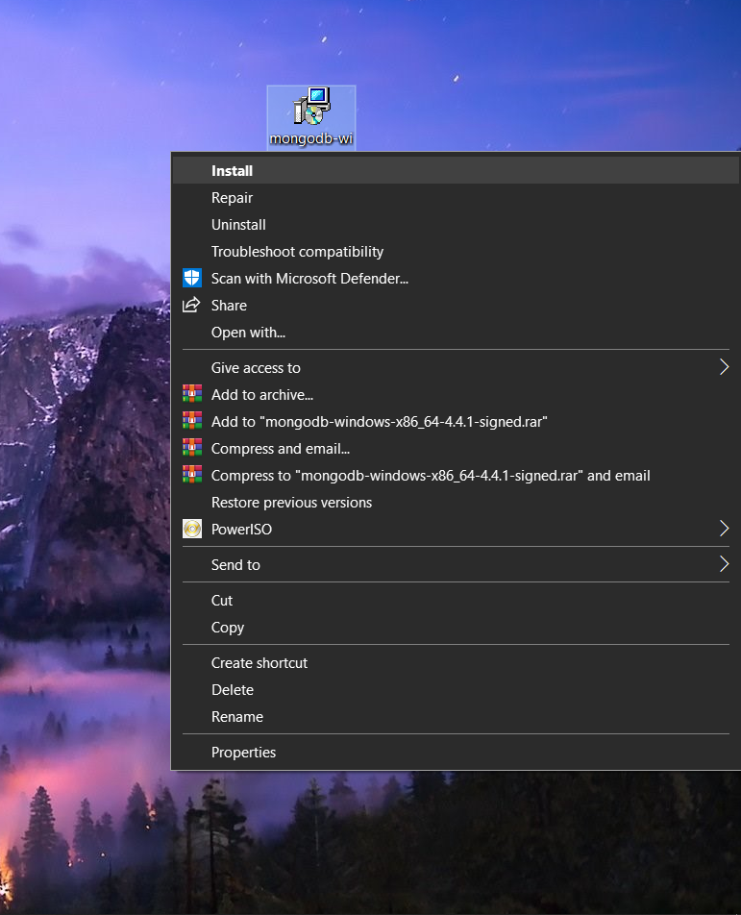

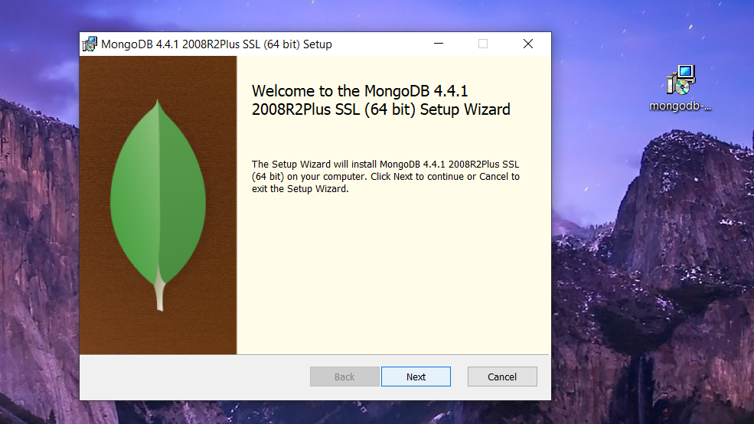

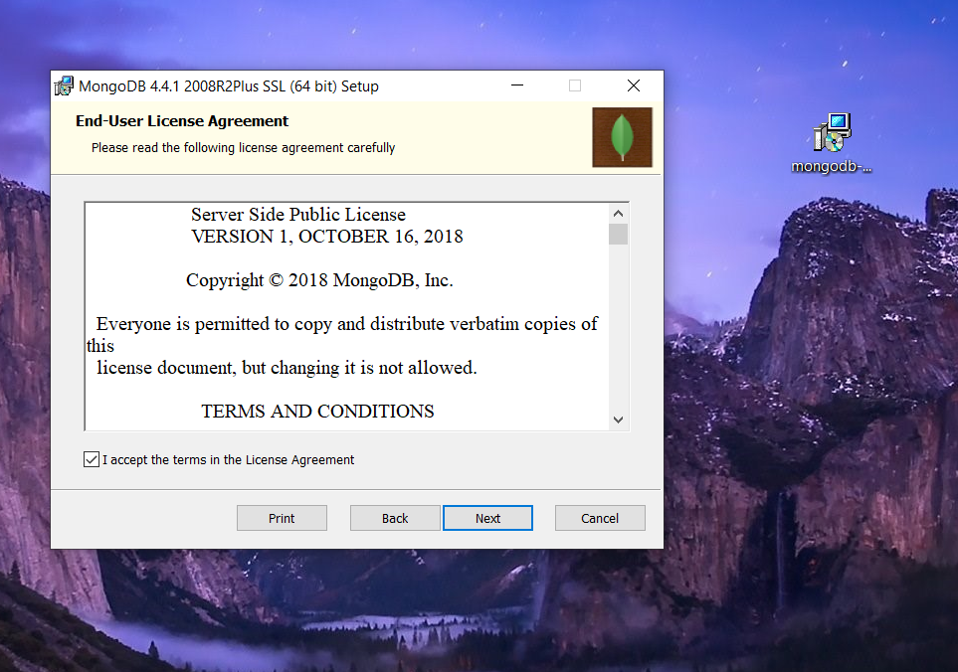

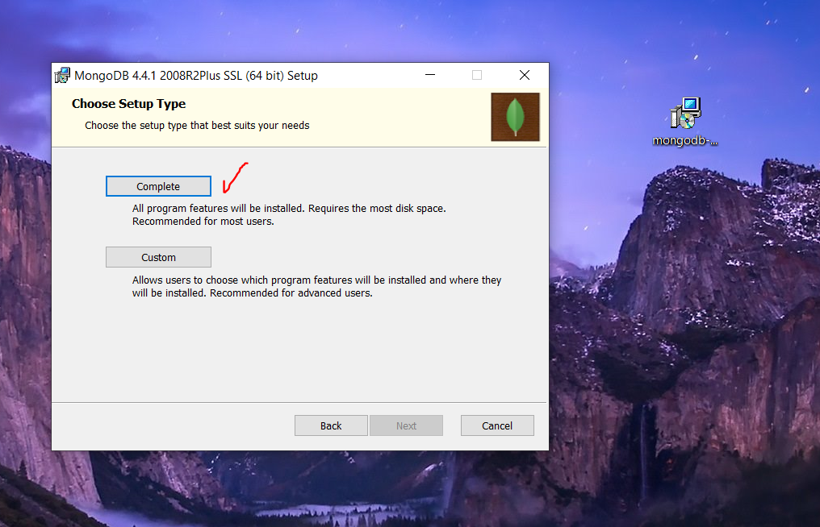

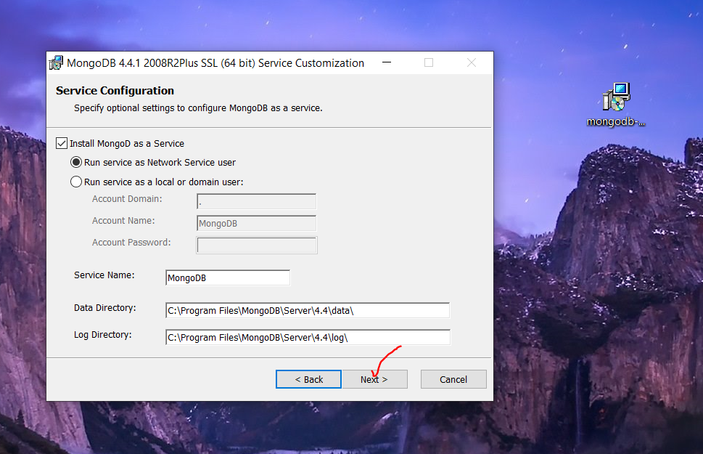

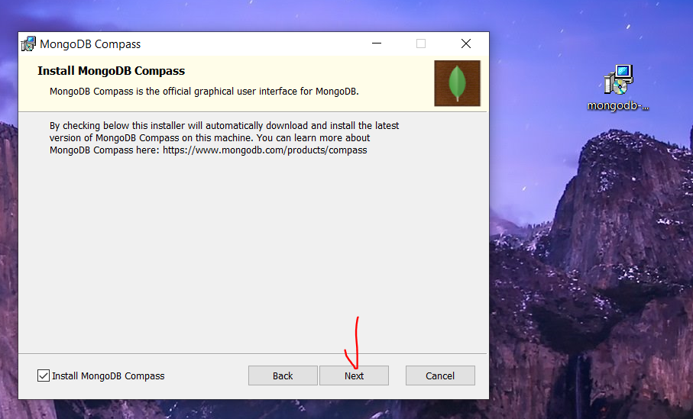

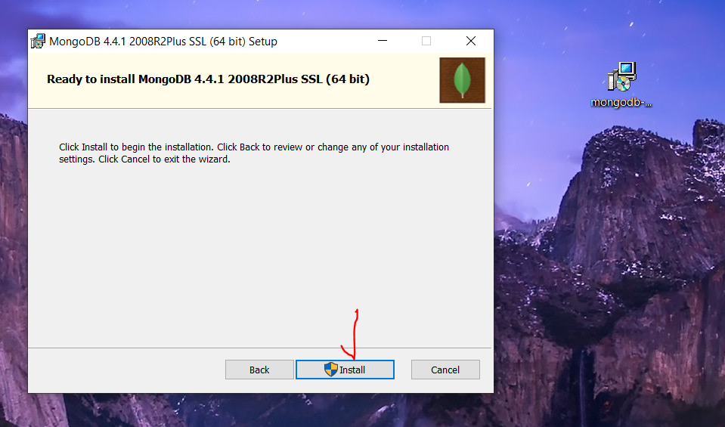

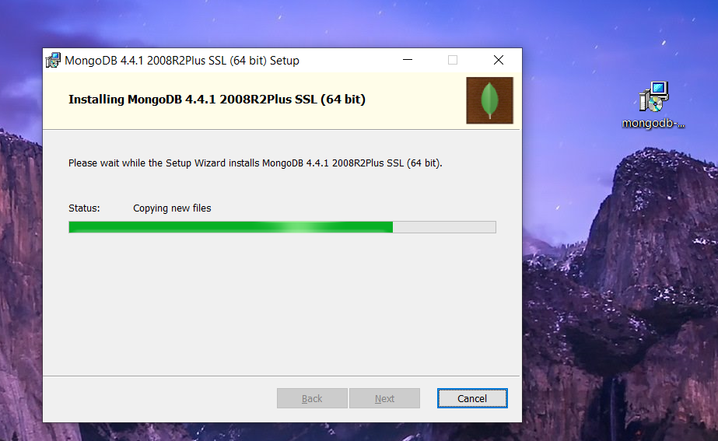

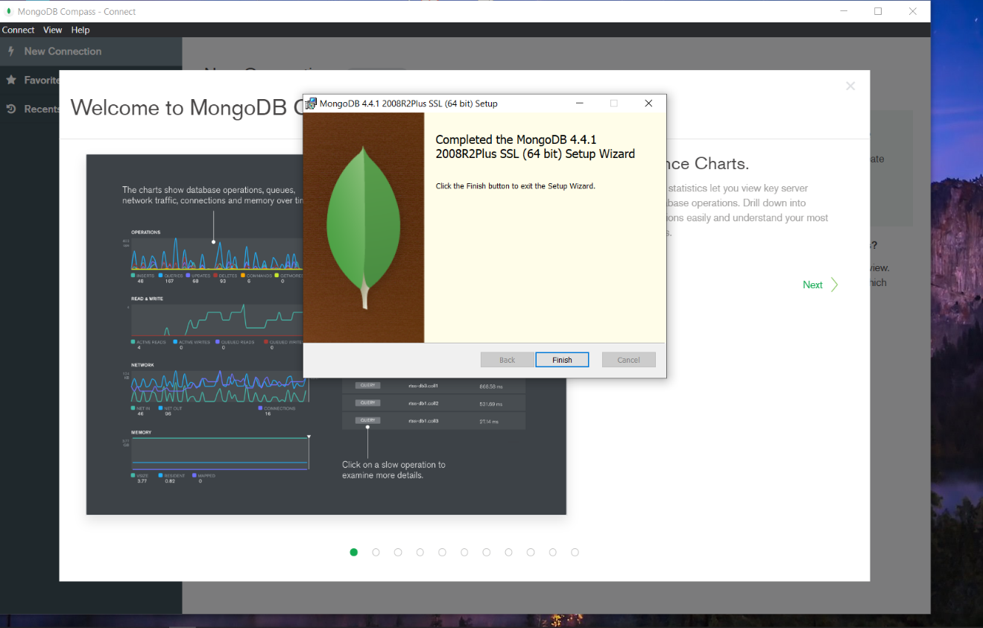

**Create First Three Database in MongoDB**

* This is the Default Databases in MongoDB Compass – Localhost27017

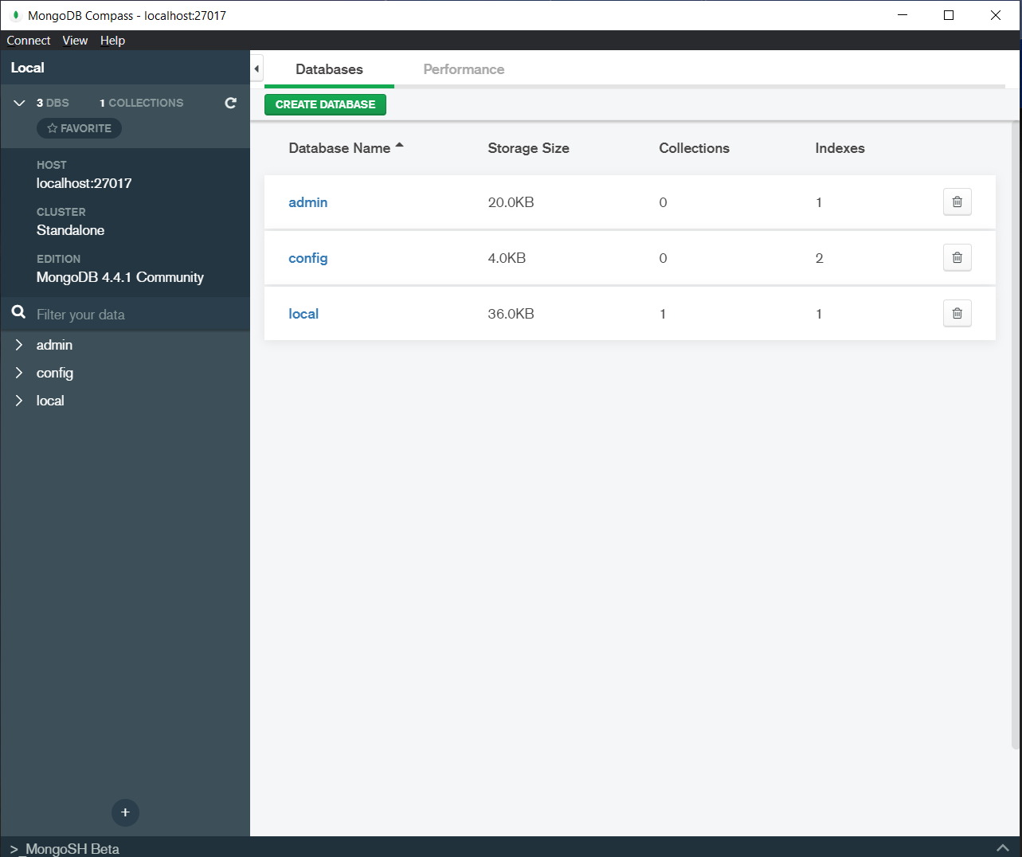

* So now I go to MongoDB in CMD

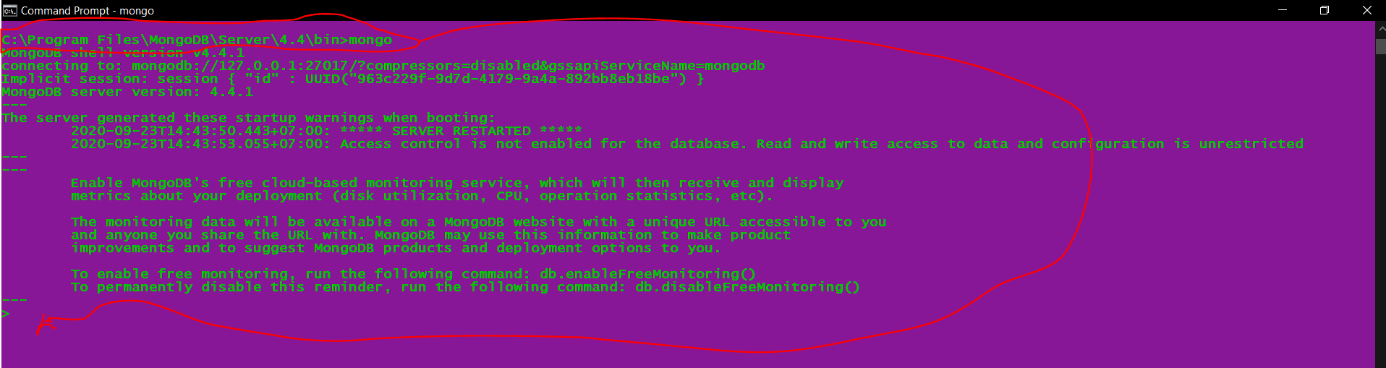

* Type: **> show dbs** to show all databases in MongoDB

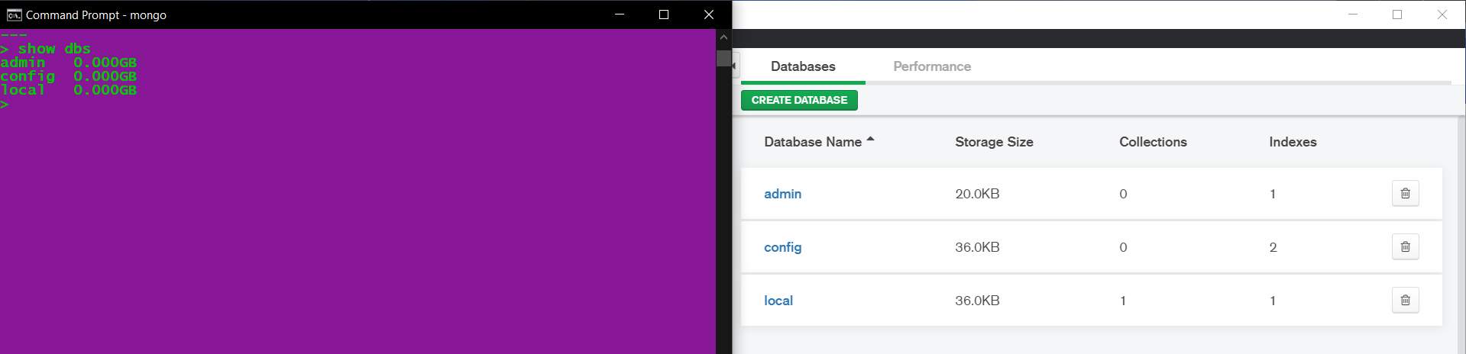

* Then, this below picture is to show how to create Databases in MongoDB using CMD

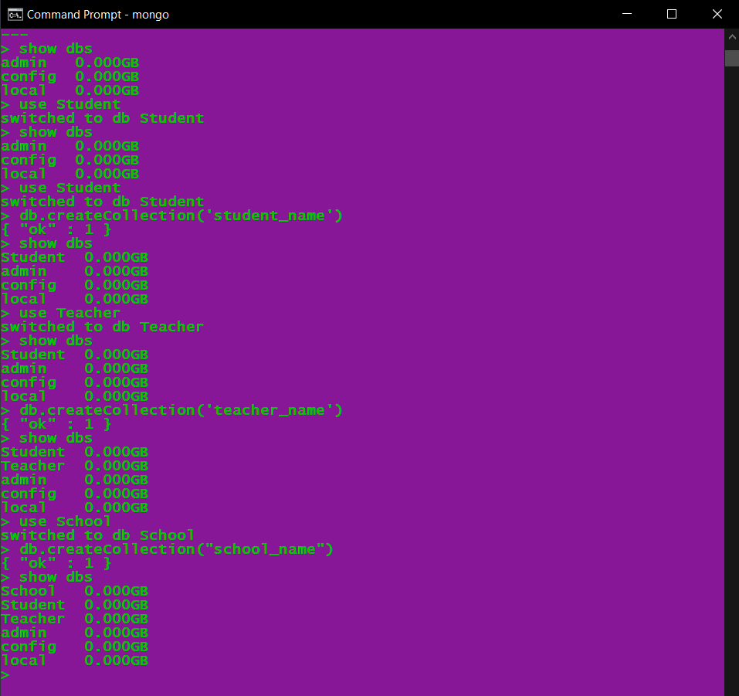

* Then, it show in MonggoDB Compass after created databases already like below:

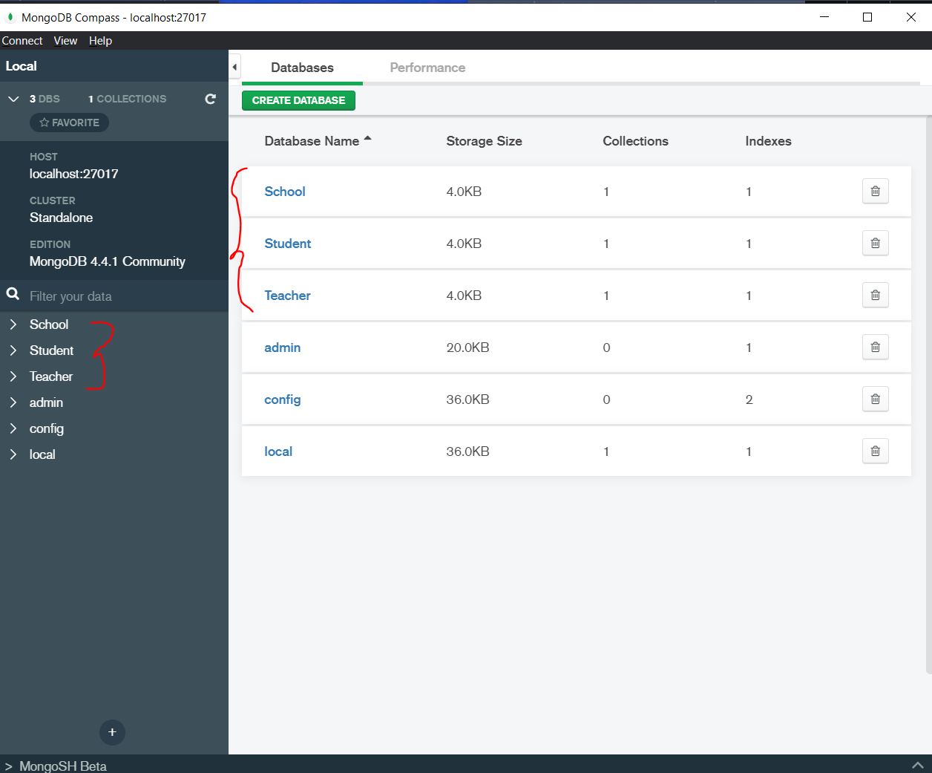

**Delete Database in MongoDB operation one by one**

* **CMD: >** db.dropDatabase() after we CMD: > use {db_name}, then delete one by one.

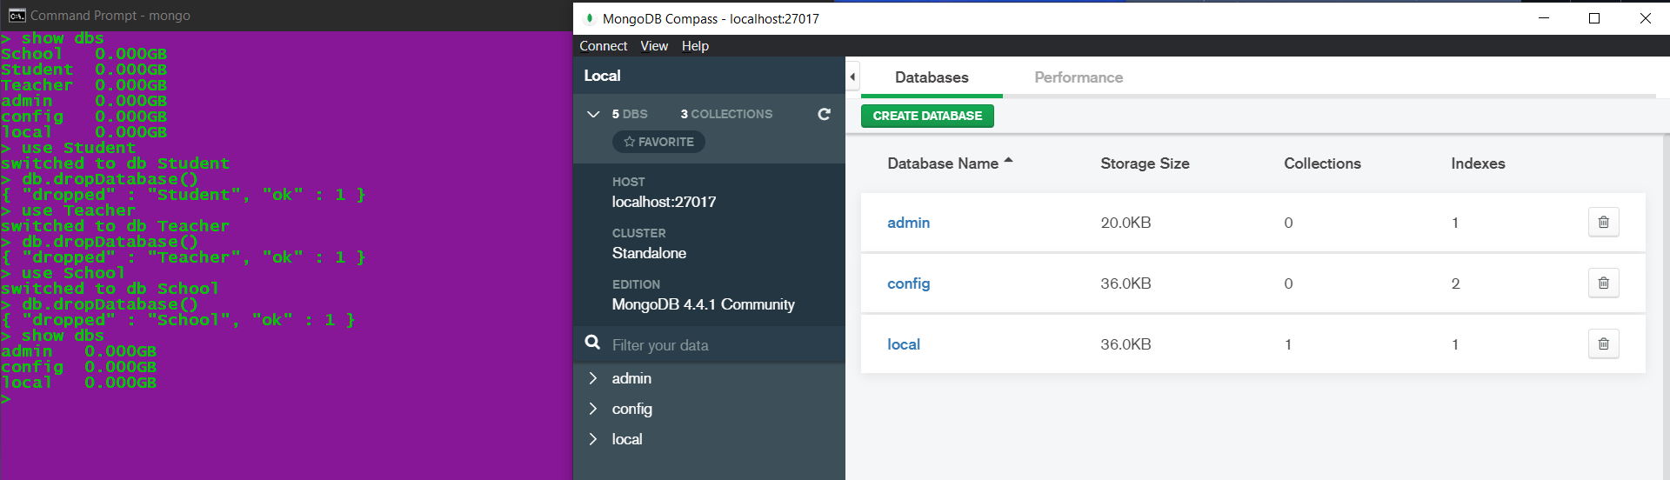

======================= **END** ==========================